Riverside University Health System – Behavioral Health
Cultural Competency Program

National Standards for Culturally and Linguistically
Appropriate Services (CLAS) in Health and Health Care

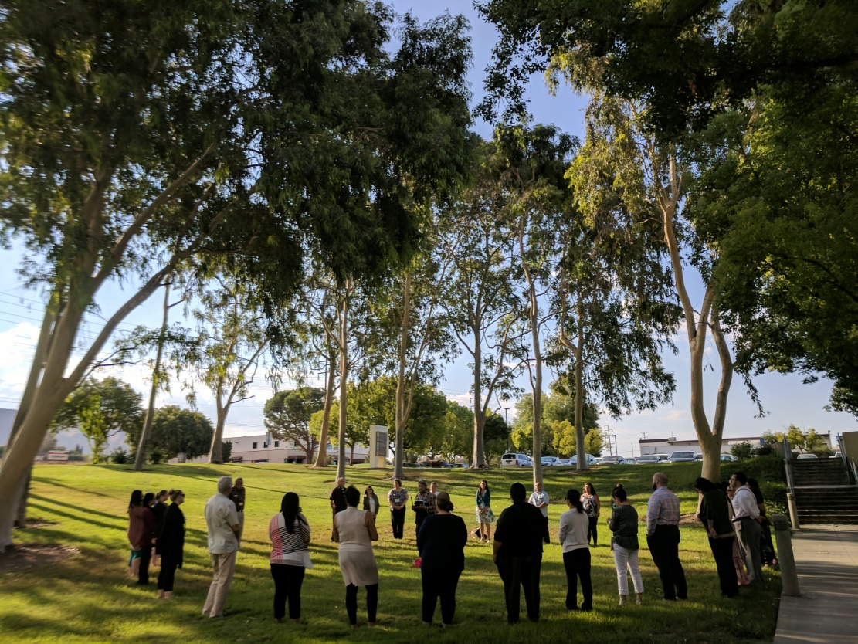

2018

THE ENHANCED NATIONAL CLAS STANDARDS

The Enhanced National Culturally and Linguistically Appropriate Standards are organized as one Principal
Standard and three themes:

Principal Standard:
1. Provide effective, equitable, understandable, and respectful quality care and services that are responsive to diverse cultural health beliefs and practices, preferred languages, health literacy, and other communication needs.

Governance, Leadership and Workforce:
2. Advance and sustain organizational governance and leadership that promotes CLAS and health equity through policy, practices and allocated resources.
3. Recruit, promote, and support a culturally and linguistically diverse governance, leadership, and workforce that are responsive to the population in the service area.
4. Educate and train governance, leadership, and workforce in culturally and linguistically appropriate policies and practices on an ongoing basis.

Communication and Language Assistance:
5. Offer language assistance to individuals who have limited English proficiency and/or other communication needs, at no cost to them, to facilitate timely access to all health care and services.
6. Inform all individuals of the availability of language assistance services clearly and in their preferred language, verbally and in writing.
7. Ensure the competence of individuals providing language assistance, recognizing that the use of untrained individuals and/or minors as interpreters should be avoided.
8. Provide easy-to-understand print and multimedia materials and signage in the languages commonly used by the populations in the service area.

Engagement, Continuous Improvement, and Accountability:
9. Establish culturally and linguistically appropriate goals, policies, and management accountability, and infuse them throughout the organization’s planning and operations.
10. Conduct ongoing assessments of the organization’s CLAS-related activities and integrate CLAS- related measures into measurement and continuous quality improvement activities.
11. Collect and maintain accurate and reliable demographic data to monitor and evaluate the impact of
CLAS on health equity and outcomes and to inform service delivery.
12. Conduct regular assessments of community health assets and needs and use the results to plan and implement services that respond to the cultural and linguistic diversity of populations in the service area.
13. Partner with the community to design, implement, and evaluate policies, practices, and services to ensure cultural and linguistic appropriateness.
14. Create conflict and grievance resolution processes that are culturally and linguistically appropriate to identify, prevent and resolve conflicts or complaints.
15. Communicate the organization’s progress in implementing and sustaining CLAS to all stakeholders, constituents, and the general public.

Table 1: COMMITMENT TO CULTURAL COMPETENCE
Objective | Ensure that RUHS-BH service delivery system meets the cultural and linguistic needs of target population by developing Cultural Competence Plan Requirements that will be distributed to all department clinics and contractors on an annual basis.
Strategies for implementation | - Post Cultural Competency Plan Requirements on website.  - Schedule presentations at management and directors meetings.  - Schedule presentations with contract agencies.  - Develop a monitoring system of compliance with plan requirements.  - Prepare list of community-based, culturally and linguistically appropriate, nontraditional mental health providers. Cultural Competence Program and Cultural Competence Reducing Disparities Committee works on identifying programs in the community.  - Create a resource list of consumer operated programs that are cultural, ethnic and linguistically specific for distribution in the community. Cultural Competence Program Manager works with Consumer Affairs, Family Advocate and Parent Partners Programs to list their programs/activities available for cultural and linguistic specific populations.
CLAS Standards Met | 1: Provides effective, equitable, understandable, and respectful quality care and services that are responsive to diverse cultural health beliefs and practices, preferred languages, health literacy, and other communication needs.  9: Establishes culturally and linguistically appropriate goals, policies, and management accountability and infuses them throughout the organizations planning and operations.  10: Conducts ongoing assessments of the organization's CLAS-related activities and integrate CLAS-related measures into measurement and continuous quality improvement activities.  12: Conducts regular assessments of community health assets and needs and uses the results to plan and implement services that respond to the cultural and linguistic diversity of populations in the service area.  15: Communicates the organization’s progress in implementing and sustaining CLAS to all stakeholders, constituents, and the general public.

Table 2: DATA COLLECTION AND ASSESSMENT OF SERVICE NEEDS
Objective | Provide measurable, quantifiable analysis of disparities by race, ethnicity, language, age, gender, and other relevant areas of the target population to ensure that consumers and family members are receiving comprehensive and respectful care in a manner compatible with their cultural health beliefs, practices and preferred language on an annual basis.
Strategies for implementation | - Penetration rates for unserved, underserved and inappropriately served populations increase 1.5 to 2% over prior year’s rate.  - Develop a Data Collection Tool and Guidelines/Protocol by April 30, 2018.  - Develop a Survey that can be used at culture/ethnic-specific special events such as the Lunar Fest and the LULAC Health Fair.  - Summarize results and incorporate into program planning operations by June 2018.  - Provide training and technical assistance for Outreach and Engagement Coordinators by May 15, 2018.  - Meet on a quarterly basis with Riverside unit to determine outcomes and progress.  - Presentation of Consumers’ Utilization Data and Clients Population Profile Report and Analysis of Disparities, “Who We Serve”, to the Cultural Competence Reducing Disparities Committee.  - Provide bi-annual Quality Management overview on mental health disparities and strategies for reducing gaps in service.  - Documentation of committee feedback on strategies.  - Identify populations with higher levels of disparities/low penetration rates.  - Create list of activities targeting hard to reach populations.  - Develop outcome measures and a contract monitoring tool that can be used with contracted providers.  - Cultural Competence Program Manager collaborates with Quality Management in developing a cultural competency contract monitoring tool.  - Review 2017 Client Satisfaction Survey Results and Client Grievance Summary.
CLAS Standards Met | 4: Educates and trains workforce in culturally and linguistically appropriate policies and practices on an ongoing basis.  10: Conducts ongoing assessments of the organization's CLAS-related activities and integrate CLAS-related measures into measurement and continuous quality improvement activities.  11: Collects and maintains accurate and reliable demographic data to monitor and evaluate the impact of CLAS on health equity and outcomes and to inform service delivery.  12: Conducts regular assessments of community health assets and needs and uses the results to plan and implement services that respond to the cultural and linguistic diversity of populations in the service area.  14: Creates conflict and grievance resolution processes that are culturally and linguistically appropriate to identify, prevent and resolve conflicts or complaints.  15: Communicates the organization’s progress in implementing and sustaining CLAS to all stakeholders, constituents, and the general public.

Table 3: COMMUNITY ENGAGEMENT
Objective | Increase Community Outreach and Engagement activities by 5% as recommended by the Cultural Competence Reducing Disparities Committee Ethnic and Cultural Community Advisory Groups and determine how they will be allocated to the program budget.
Strategies for implementation | - Hispanic/Latino Advisory Group  - Collaboration with Consulate of Mexico for Ventanilla de la Salud, Binational Health Fair, and Binational Health Week.  - Advocacy for new Promotores(as) de Salud Mental program.  - Participation in UCR School of Medicine’s Latino Health Project addressing the communities of Arlanza, Eastside and Casa Blanca.  - Partnership with Community Settlement Association for Nosotros Family Wellness Group in Eastside.  - Participation in Annual LULAC Health Fair.  - Adopting grassroots approach to community Mental Health with Dr. Carlos Fernandez.  - Asian American Task Force (AATF)  - Actively promote RUHS-BH services and resources to the Asian American community and identify opportunities for partnership in community events geared toward reaching Asian American communities (e.g., Downtown Riverside Lunar Fest, Asian Heritage Month, etc.)  - Collaborate with local business and non-profit organizations, such as the Perris Valley Filipino American Association (PVFAA) and Asian American serving spiritual organizations, through active participation in cultural traditions (i.e. festivals and history and heritage celebration activities), to increase cultural pride and mental health awareness.  - Establish a Filipino and/or other Asian American resource center for the underserved populations of Riverside County by rendering a list of resources and entities that provide culturally competent/responsive services (e.g., clinics, other social/health needs).  - Conduct seminars and workshops that increase community awareness of mental health, recovery, and well being.  - Advocate for community awareness of the mental health needs of Transition-Age Youth in the Asian American population.  - African American Family Wellness Advisory Group (AAFWAG)  - Plan two annual events focusing on women’s wellness.  - African American Wellness Roundtable – partnership with the HELI Project to identify issues and share information on services and resources.  - Participation in the development and implementation of the girl’s Building Resiliency in African American Families (BRAAF) Program.  - Participation in community engagement activities that celebrate African-American culture including, but not limited to, Black History events, Juneteenth celebrations, community programs that celebrate cultural events in the African-American community (i.e. Kwanzaa), and Martin Luther King Day events.
- Community Advocacy for Gender and Sexuality Issues (CAGSI)
- The LGBTQ Community Peer Educator Program (C-PEP) - Community based focus groups to conducted to introduce the approved C-PEP curriculum. C-PEP is the grassroots education LGBTQ Community Mental Health 101 Project. Facilitators strategic sessions include "Coming Out", Suicide within the LGBTQ community, and Depression.
- Transgender Youth Empowerment Program (TYEP) - TYEP targets vulnerable transgender youth who possess leadership potential, but lack opportunities to develop it in a positive way. Youth (ages 13 to 21) are taught leadership skills, civic engagement, critical thinking, and team building and are provided with monthly empowerment sessions. The Trans*Formation series provides education, training and support to help create a gender sensitive and inclusive environment for children, teens and their families.
- Collaboration with PFLAG and community outreach subcommittees, Desert Region Health Access for Trans-Community (Palm Springs) TDOR Palm Springs.
- Continue Community Education and Outreach by participating in Palm Springs PRIDE Festival and giving presentations to participants in diverse groups including, but not limited to: the faith community, foster parents, RUHS-BH staff, and consumers and family members, and other community groups.
- Participation in Transgender Workgroup for gender non-binary children.
- Native American Wellness Council
- Develop a series of 4 workshops on Utilizing Decolonizing, Revitalization, Mindfulness and Traditional Practices for RUHS-BH staff. Use storytelling as part of Cultural Competency Program’s outreach to Natives.
- Promote and attend California Indian Conference with Native Community Helpers
- Deaf and Hard of Hearing
- Continue the Cooperative Agreement between Center for Deafness Inland Empire (CODIE) and RUHS-BH.
- Review and finalize 5 videos on mental health topics for the DHH community.
- Blind and Visually Impaired
- Establish a Cooperative Agreement between Blindness Support Services and RUHS-BH Monthly Mental Health Awareness meeting with Blind community at the Blindness support Services in Riverside.
- Monthly counseling/education and referrals provided by the Western Outreach and Engagement Coordinator Clinician.
- Provide Blindness Awareness Training to RUHS-BH staff.
- Monthly meetings with Staff Analyst regarding allocation of funds/budget.
- Staff Analyst to develop Budget Expenditure Reports as needed.
CLAS Standards Met | 1: Provides effective, equitable, understandable, and respectful quality care and services that are responsive to diverse cultural health beliefs and practices, preferred languages, health literacy, and other communication needs.  9: Establishes culturally and linguistically appropriate goals, policies, and management accountability and infuses them throughout the organizations planning and operations.  13: Partners with the community to design, implement and evaluate policies, parties, and services to ensure cultural and linguistic appropriateness.

Table 4: INTEGRATION OF COMMUNITY STAKEHOLDERS WITHIN BEHAVIORAL HEALTH SYSTEM
Objective | Develop and recruit members for the Cultural Competence Reducing Disparities Committee (CCRD) and the Ethnic/Cultural Specific Advisory Groups. Ensure committee members are representative of the diverse community and that they have active participation in the MHSA stakeholder process.
Strategies for implementation | - Cultural Competence and Ethnic Service Manager maintains a list of members of the committees by organization/agencies, their self-identified membership affiliation and language preference.  - CCRD committee meetings provide interpretation services, including American Sign Language at all meetings to ensure language access to members.  - Cultural Competence Program Manager (CCPM) participates in Quality Assurance/Quality Improvement (QI) Committee. CCPM provides reports to the QI committee of CCRD recommendations on a monthly basis.  - CCRD committee participates in the review and provides feedback of MHSA planning and stakeholder process. MHSA Program Administration presentation to CCRD regarding planning and stakeholder process.  - CCRD committee participates in the review and implementation of programs, including the MHSA program components. CCRD committee members and Community Liaison Consultants actively participate in the development and implementation of programs designed to reach their target populations.
CLAS Standards Met | 5: Offers language assistance to individuals who have limited English proficiency, at no cost to them, to facilitate timely access to all healthcare and services.  6: Informs all individuals of the availability of language assistance services clearly and in their preferred language, verbally.  9: Establishes culturally and linguistically appropriate goals, policies, and management accountability and infuses them throughout the organizations planning and operations.  13: Partners with the community to design, implement and evaluate policies, parties, and services to ensure cultural and linguistic appropriateness.

Table 5: WORKFORCE DEVELOPMENT
Objective | Continuous recruitment and retention of ethnically, culturally, and linguistically diverse staff at all levels of the organization to better provide services to the identified unserved and underserved populations reported in the Workforce Education and Training component of the MHSA. Increase the direct service staff by 5% annually to reflect racial, cultural and linguistic composition of the community.
Strategies for implementation | - Presentation of workforce report to the CCRD and QI committees with recommendations on targeted recruitment and retention strategies.  - Periodic updates from Workforce Education and Training (WET) Program and presentation of WET outcomes at the CCRD for feedback and recommendations.  - Cultural Competency Manager tasked with ongoing assessment of current workforce and participates as member of WET Steering Committee.  - Improve Cultural Competency program staffing infrastructure.  - Hire full time planner position.  - Recruit and hire Quality Management Research Assistant position.  - Develop agreement for Senior Parent Partner position.  - Develop Senior Consumer Specialist position.  - Retain 3 FTE Regional Outreach and Engagement Coordinator positions.  - Identify Deaf and Hard of Hearing Outreach and Engagement Consultant.  - Service agreements with Community Leaders experts to function as Community Liaison/ Consultants for African Americans, Native Americans, Asian Americans, LGBTQ, Deaf and Hard of Hearing, and Blindness Support and faith-based leaders.
CLAS Standards Met | 2: Advances and sustains organizational governance and leadership that promotes CLAS and health equity through policy, practices, and allocated resources.  3. Recruits, promotes, and supports a culturally and linguistically diverse governance, leadership, and workforce that are responsive to the population in the service area.  4: Educates and trains workforce in culturally and linguistically appropriate policies and practices on an ongoing basis.  9: Establishes culturally and linguistically appropriate goals, policies, and management accountability and infuses them throughout the organizations planning and operations.  10: Conducts ongoing assessments of the organization's CLAS-related activities and integrate CLAS-related measures into measurement and continuous quality improvement activities.

Table 6: WORKFORCE NEEDS ASSESSMENT
Objective | Collaborate with Workforce Education and Training (WET) program to plan, organize, and implement an assessment that captures the diversity and cultural competence training needs of our workforce.
Strategies for Implementation | - Use CLAS Standards, CBMCS Tool and San Diego County’s Assessment as references to design an individualized survey that will gather feedback from RUHS-BH staff regarding training needs and providing culturally responsive services. The survey will be distributed electronically to all RUHS-BH staff and will also provide an opportunity to obtain demographic information that will capture the department’s diversity.  - Supplement findings from survey with in-depth qualitative data by facilitating a focus group (November 2018). Identify 10 RUHS-BH employees that represent a diverse (geographic, hierarchical, gender, etc.) selection of the workforce. For optimal results, participants with the following classifications are desired:  - Executive Team  - Management/Administration  - Line Supervisor  - Clinical Therapist  - Behavioral Health Specialist  - Peer Support Specialist  - Family Advocate  - Parent Partner  - Office Assistant  - Prepare a summary report of the focus group as well as results from the survey that will be presented to Directors and Managers. Findings from these assessment tools will inform training recommendations and allow WET and Cultural Competency Program to identify training priorities, potential speakers, and topics of interest.
CLAS Standards Met | 2: Advances and sustains organizational governance and leadership that promotes CLAS and health equity through policy, practices, and allocated resources.  4: Educates and trains workforce in culturally and linguistically appropriate policies and practices on an ongoing basis.  10: Conducts ongoing assessments of the organization’s CLAS-related activities and integrates CLAS- related measures into measurement and continuous quality improvement activities.  11: Collects and maintains accurate and reliable demographic data to monitor and evaluate the impact of CLAS on health equity and outcomes and to inform service delivery.

Table 7: WORKFORCE TRAINING
Objective | Provide annual Cultural Competence training for RUHS-BH staff and contract agencies including management, clinical and support staff. By the end of 2018, 50% of direct services staff and supervisors will have completed Cultural Competence Training.
Strategies for Implementation | - Provide annual county staff and contract agencies staff with a 4-hour training that focuses on the department’s implementation of Cultural Competence Plan Requirements.  - CCPM develops a training curriculum to present a summary of the CCPR and recommendations for implementation of goals and objectives.  - Provide county staff and contract agencies staff with California Brief Multicultural Training Program (CBMCS).  - 1-day CBMCS Training & 1-day of practical applications  - 1-day training on Cultural Competence Assessments and Treatment Plan for Mental Health Clinicians.  - 1-day Training on Cultural Competence Supervision for Mental Health Clinic Supervisors and Program Managers.  - Provide county department staff and contract agencies staff with 4-hour training on how to provide services using interpreters.  - Biannual training on the guidelines for using interpreters in the work setting, designed for bilingual staff and mental health providers providing interpretation services.  - Plan, organize, and host Cultural Competence Summit that will:  - Foster interdepartmental and statewide collaboration in the event planning process (program, logistics, decorations, entertainment, and sponsorship/marketing) as well as during the 2-day conference.  - Provide culture-specific training to staff, providers, and professionals in the mental health and substance abuse fields through a wide variety of workshops and a diverse selection of keynote speakers (Native American, African American, Transgender, Asian, Latin).  - Incorporate and honor cultural values from the various underserved communities including Native American, African American, Asian American, LGBTQ, Immigrants, and Latinx.  - Promote healing and facilitate safe spaces among attendees.  - Offer Continuing Education credits.  - Provide Department staff and contract agencies staff with Ethnic and Cultural Specific Trainings for at least 3 underserved communities specific to:  - LGBTQ / TransYouth Beyond Gender Binary  - Native American (California/Arizona)  - African-American (Afro-Centric teachings)  - Latino Community  - Asian American (Chinese, Filipino, Cambodian, Korean, Hmong & Laotian)  - Deaf and Hard of Hearing Culture  - Blind and Visually Impaired Community
CLAS Standards Met | 1: Provides effective, equitable, understandable, and respectful quality care and services that are responsive to diverse cultural health beliefs and practices, preferred languages, health literacy, and other communication needs.  2: Advances and sustains organizational governance and leadership that promotes CLAS and health equity through policy, practices, and allocated resources.  3. Recruits, promotes, and supports a culturally and linguistically diverse governance, leadership, and workforce that are responsive to the population in the service area.  4: Educates and trains workforce in culturally and linguistically appropriate policies and practices on an ongoing basis.  7: Ensures the competence of individuals providing language assistance, recognizing that the use of untrained individuals and/or minors as interpreters should be avoided.

Table 8: LANGUAGE CAPACITY
Objective | Building the Department capacity to address language needs by reducing language access barriers and providing consumers and family members with services and written materials such as forms, brochures, and fliers, in their language of choice.
Strategies for Implementation | - Review and update RUHS-BH translation policy and protocol for incoming Translation Requests to be distributed to all program managers.  - Select Chair of Translation Committee to serve 2-year term.  - Compile approved translation documents on shared drive once request is processed.  - Translation Services and list of documents saved on the Shared Translation Drive for easy access. Cultural Competence Program responds to requests for translation services in compliance with Department policy regarding translations, including maintaining Shared Translation Drive.  - Monitor access and accuracy to CARES Line voice messages for Spanish threshold language on a quarterly basis.  - Review English voice messages by March 15, 2018.  - Obtain approved Spanish versions from Cultural Competency Program’s Translation Committee by March 25, 2018.  - Identify staff with proficient linguistic capability in Spanish to record messages by March 30, 2018.
CLAS Standards Met | 1: Provides effective, equitable, understandable, and respectful quality care and services that are responsive to diverse cultural health beliefs and practices, preferred languages, health literacy, and other communication needs.  4: Educates and trains workforce in culturally and linguistically appropriate policies and practices on an ongoing basis.  5: Offers language assistance to individuals who have limited English proficiency, at no cost to them, to facilitate timely access to all healthcare and services.  6: Informs all individuals of the availability of language assistance services clearly and in their preferred language, verbally.  7: Ensures the competence of individuals providing language assistance, recognizing that the use of untrained individuals and/or minors as interpreters should be avoided.  8: Provides easy-to-understand print and multimedia materials and signage in the languages commonly used by the populations in the service area.  13: Partners with the community to design, implement, and evaluate policies, practices, and services to ensure cultural and linguistic appropriateness.

